**Smart Library**

**Introduction: -**

Expeditious urbanization is leading to smarter cities with the intention to provide core infrastructure and a decent quality of life to its citizens, a clean and sustainable environment. Smartness can be established in any sector of the urban area: be it in an office, school, transportation infrastructure, library etc.

Our idea is centralized to a library with focus on energy consumption, security, safety and comfort of its occupants. The sensors provide the current information about the temperature, humidity, light, motion in the library. The raw data is transformed into context data by the input drivers. Energy consumption is controlled prudently by handling the lighting system, HVAC and burglar system dynamically after performing modification on the context data. Security is obtained by the alarming system in case of unexpected and malicious entry into the environment under consideration during closed hours .

**System Design: -**

Fig 1 gives the system architecture:

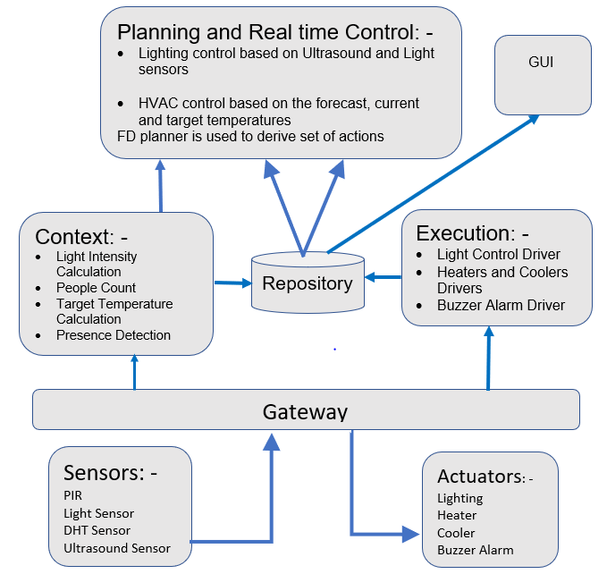

Set-up and Implementation: -

SW and HW structure:

Hardware Used: RaspberryPi Pi3 B+ with Groove Pi set and Plugwise Set.

Raspberry Pi is used as the central Gateway of the System which interacts with the sensors and actuators and also with the server for data storage. A GUI is implemented in the server side for displaying the current system Status and also to plot the recorded data.

Top Level



The software design is as follows:

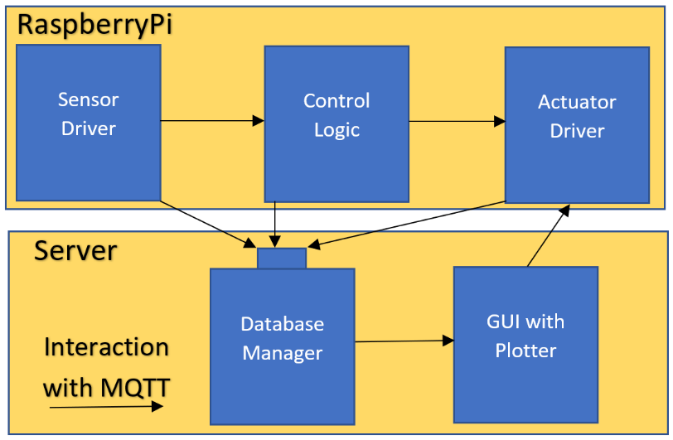

The hardware design:



Working

people count

To efficiently control the lighting and heating of a building we should first be aware of the number of people inside the building. Here we use ultrasound sensors placed at the entry point of a building. Ultrasound sensor gives the distance of an object in front of it and we use this to detect if the person has entered or exited. For example: if the door width is 1 meter, then the sensor reading will be 1m and when a person enters or exits the room, the sensor reading reduces. This reduction in the distance is detected and used to count the number of people crossing the door. Assumption here is that we have two separate doors for entry and only one person at a time can go through the door since we are using only one ultrasound sensor.

Light

Lighting is a very important factor for the people in the library. General light intensity recommended for a library is around 500 Lux[1]. Lights are switched ON or OFF only if there are people inside the library and otherwise by default all the lights are switched OFF. The raw value received from the analog light sensor is classified into 4 levels namely Dark, Low, Medium and High (assumption). The threshold used for this classification can be customised based on the lighting conditions naturally available in the room. The four brightness levels are mapped to the light sensor detected intensity values. Another assumption made here is the library is naturally illuminated and the sensor gives the intensity of the light coming from outside. If this light intensity is dark that means there is no light from the outside, then we turn on the light with full brightness and by doing this we get the recommended lux level. If the sensed light intensity is low or medium Intensity, we turn on the light with medium or low brightness respectively. An Internal schedule algorithm which is synchronised with the opening and closing time is used to know the library status.

<https://www.noao.edu/education/QLTkit/ACTIVITY_Documents/Safety/LightLevels_outdoor+indoor.pdf>

HVAC System

The main purpose of the HVAC system is to maintain a constant temperature and humidity that is ideal for a library. Care must be taken to maintain an ambience that is suitable for both the books that the library preserves and the people who visit.

A stable temperature of 21 deg Celsius is to be maintained in a library with a relative humidity in the range of 30%-50%. [2] Humidity and temperatures below the recommended range is also preferred for the preservation of books but since it is not comfortable for people inside library, a temperature of 23 deg Celsius and 30%-50% humidity is perpetuated.

In our project, we check for the current temperature in the room from the sensor as well as the temperature forecast every six hours and we compare it with the target temperature that is 23 deg Celsius. The various conditions that we look into are:

* An array of temperatures of every hour in a day is stored.
* Average of temperatures for every 6 hours is recorded and saved as the forecast temperature.
* Depending on the time of day, the current room temperature (sensor reading) is compared with the forecast and a decision is made as to which appliance out of the two, heater or cooler has to be working. If the sensor temperature is greater than the forecast, then we know that the cooler has to be turned on for that duration of 6 hours and the heater has to be turned on if the vice versa happens. This ensures that during winter only the heater will be working and during summer, the cooler and hence saves energy.
* If the forecast gives a higher than target temperature and the current temperature is lower than the target, then we keep both the cooler and heater turned off as the environment would take care of bringing up the current room temperature to target. The same decision is made vice versa. This is an efficient way of reducing the energy consumption.
* Every fixed interval, the sensor temperature is recorded and compared with the target temperature.
* Since the human body as well as a lighted bulb radiate heat energy, we have considered the effect of the presence of people and light on the room temperature and lowered the target temperature accordingly. The rise in temperature of the room is considered to be 0.1 deg C per person and 0.5 deg C per LED (assumption).
* When the humidity is lesser than 30%, the humidifier is turned on and when greater than 50%, the dehumidifier is turned on.

Burglar Alarm System

The burglar alarm system is designed to detect intrusion or unauthorized entry of a person after the working hours of the library. The PIR motion sensor detects for any movement at library during the closed hours and turns on the buzzer, which alerts the librarian. The buzzer stops when it has been turned off manually by the librarian.

2 : <https://www.nedcc.org/free-resources/preservation-leaflets/2.-the-environment/2.1-temperature,-relative-humidity,-light,-and-air-quality-basic-guidelines-for-preservation>

Database and GUI

For the purpose of storing the data, we are using a relational database management system, SQLite.

The querying of data in the SQLite database using Python is done as follows:

1. A connection is established to the database by creating a Connection object
2. A cursor object is created using the cursor method of the Connection object
3. Insert statement is used to add elements to the database
4. Select statement is used to select the records in the database
5. The fetchall() or fetchone() method is called depending on the action required of the cursor to fetch the data
6. After accessing the database, close the cursor and the database by using the close method for the cursor and connection object

Our database stores data in the form of a table with its contents as Date stamp, Topic and Sensor data. The data to be stored is received via MQTT. The database script subscribes to two topics, namely SmartCities and Database. SmartCities topic corresponds to the data from the sensor script and Database topic to the actuator script. At the time of reception, the time is calculated in the format “YYYY-MM-DD HH-MM-SS” ,using the datetime library. The topic and the corresponding data is stored. A change in data is stored in the database.

The database that is created is stored as a file with .db extension which can be viewed using the <https://inloop.github.io/sqlite-viewer/> .

GUI

The real time data is displayed using a graphical user interface, Tkinter provided by Python.

The main window is titled Smart Library, Group 25. The widgets used in the system are labels, buttons, option-menu and checkboxes. An option for plotting the data stored in the database is provided with (x,y) axis as (date stamp, data). Matplotlib library is used for plotting the graphs. A Buzzer Override button is provided to the user to manually turn it off. This GUI retrieves data from the database that was created and displays real time data at the interval of 2s (can be varied).

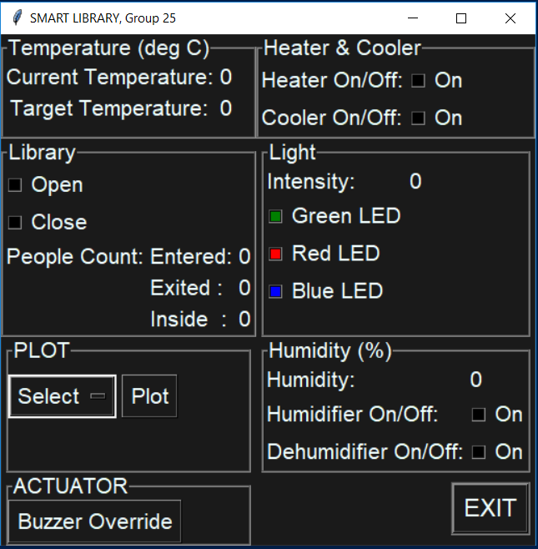

Discussion and Conclusion: -

Our system is tested successfully for light control, HVAC control by turning on and off the plugwise circles , buzzer operation. The assumptions made are as follows. The HVAC system considered is a simple, basic on/off control wherein if the temperature is below the set point, cooler is turned on and if the temperature rises above the set point, heater is turned on. Second assumption is the rise in the temperature of the room depending on the number of people in the room; a hard coded value is used for this purpose while in the real time scenario this is not the case. To cope up in this situation, calibrations are needed to understand the temperature rise for a group of people. Another similar assumption as previous is the temperature increase due to the lights. With our implementation, there exists energy conservation when considering the existing system in the library. However with the cons mentioned previously, our implementation is a crude one and definitely needs extensions to meet the real time application.